Popular Photo Editing Trends on Instagram

Instagram is one of the most famous social media platforms around the globe. Everyone likes taking incredible photos and innovatively editing them to gain a high fan following. Different photo editing techniques have made things easier for brands and companies to attract more customers to their feed. Incorporating pictures, graphics and narratives bring a pleasant, informal aesthetic to the Instagram posts. They're a compelling way to build variety to the feed, boost word-based images, and add vibrancy and innovation to your account.

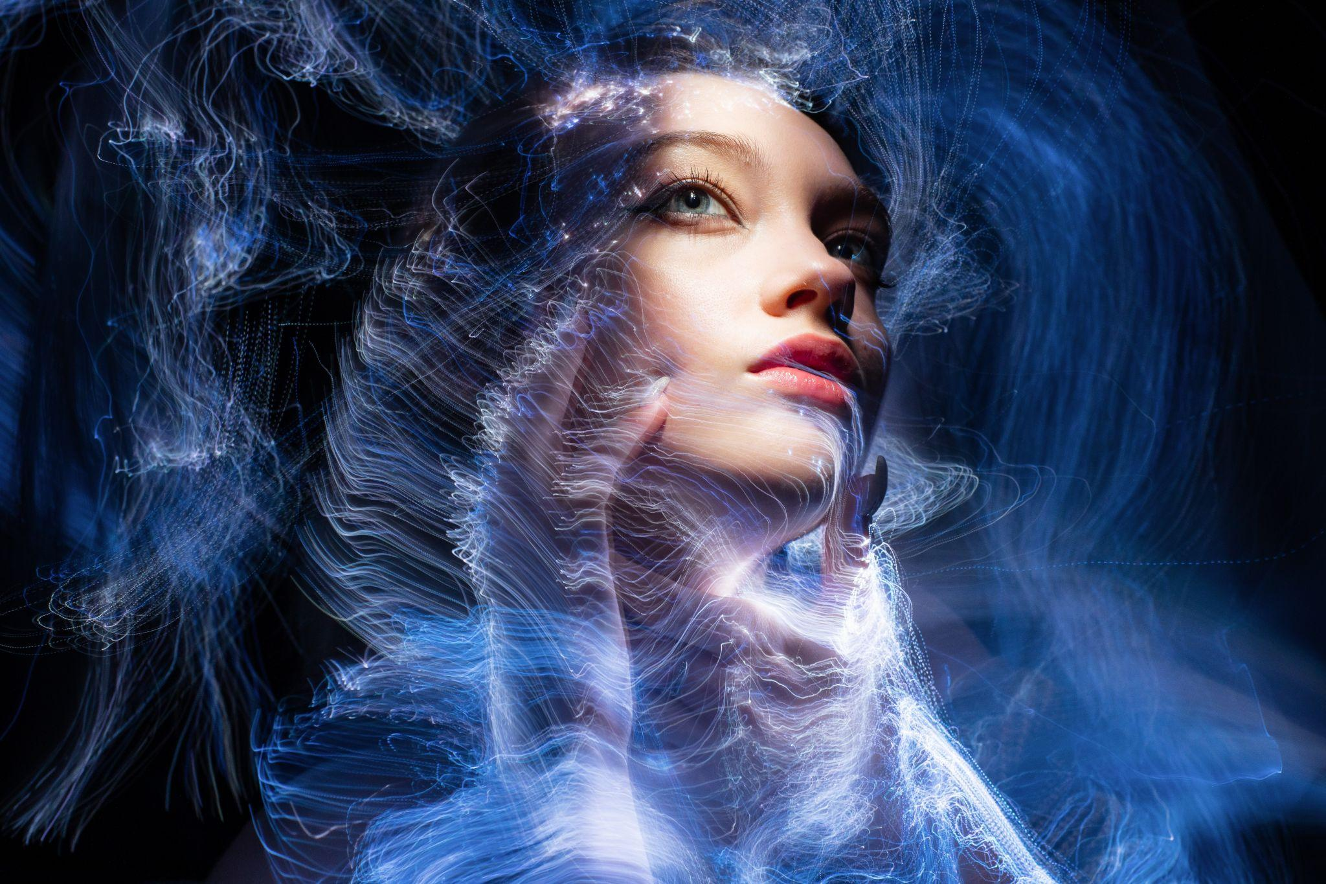

Are you still worried about practicing those techniques because photo editing tools are so frustrating?

Well, Not Anymore!!

Cutout.pro is a website that offers many AI tools that could reduce your effort to just one click. Photo Enhancer, Photo Animer and Photo Colorizer by this website are the best tools to get high-quality images. Its image cutter could help you cut pictures or remove undesirable objects from photos. You can cut out background or remove undesired people from photos with its background removal tool.

Many engaging editing techniques work incredibly impressively to make your feed look artistic and aesthetically pleasing. Following are some of the modern photo editing techniques that have been so popular these days.

## The Monochrome Photo Edit

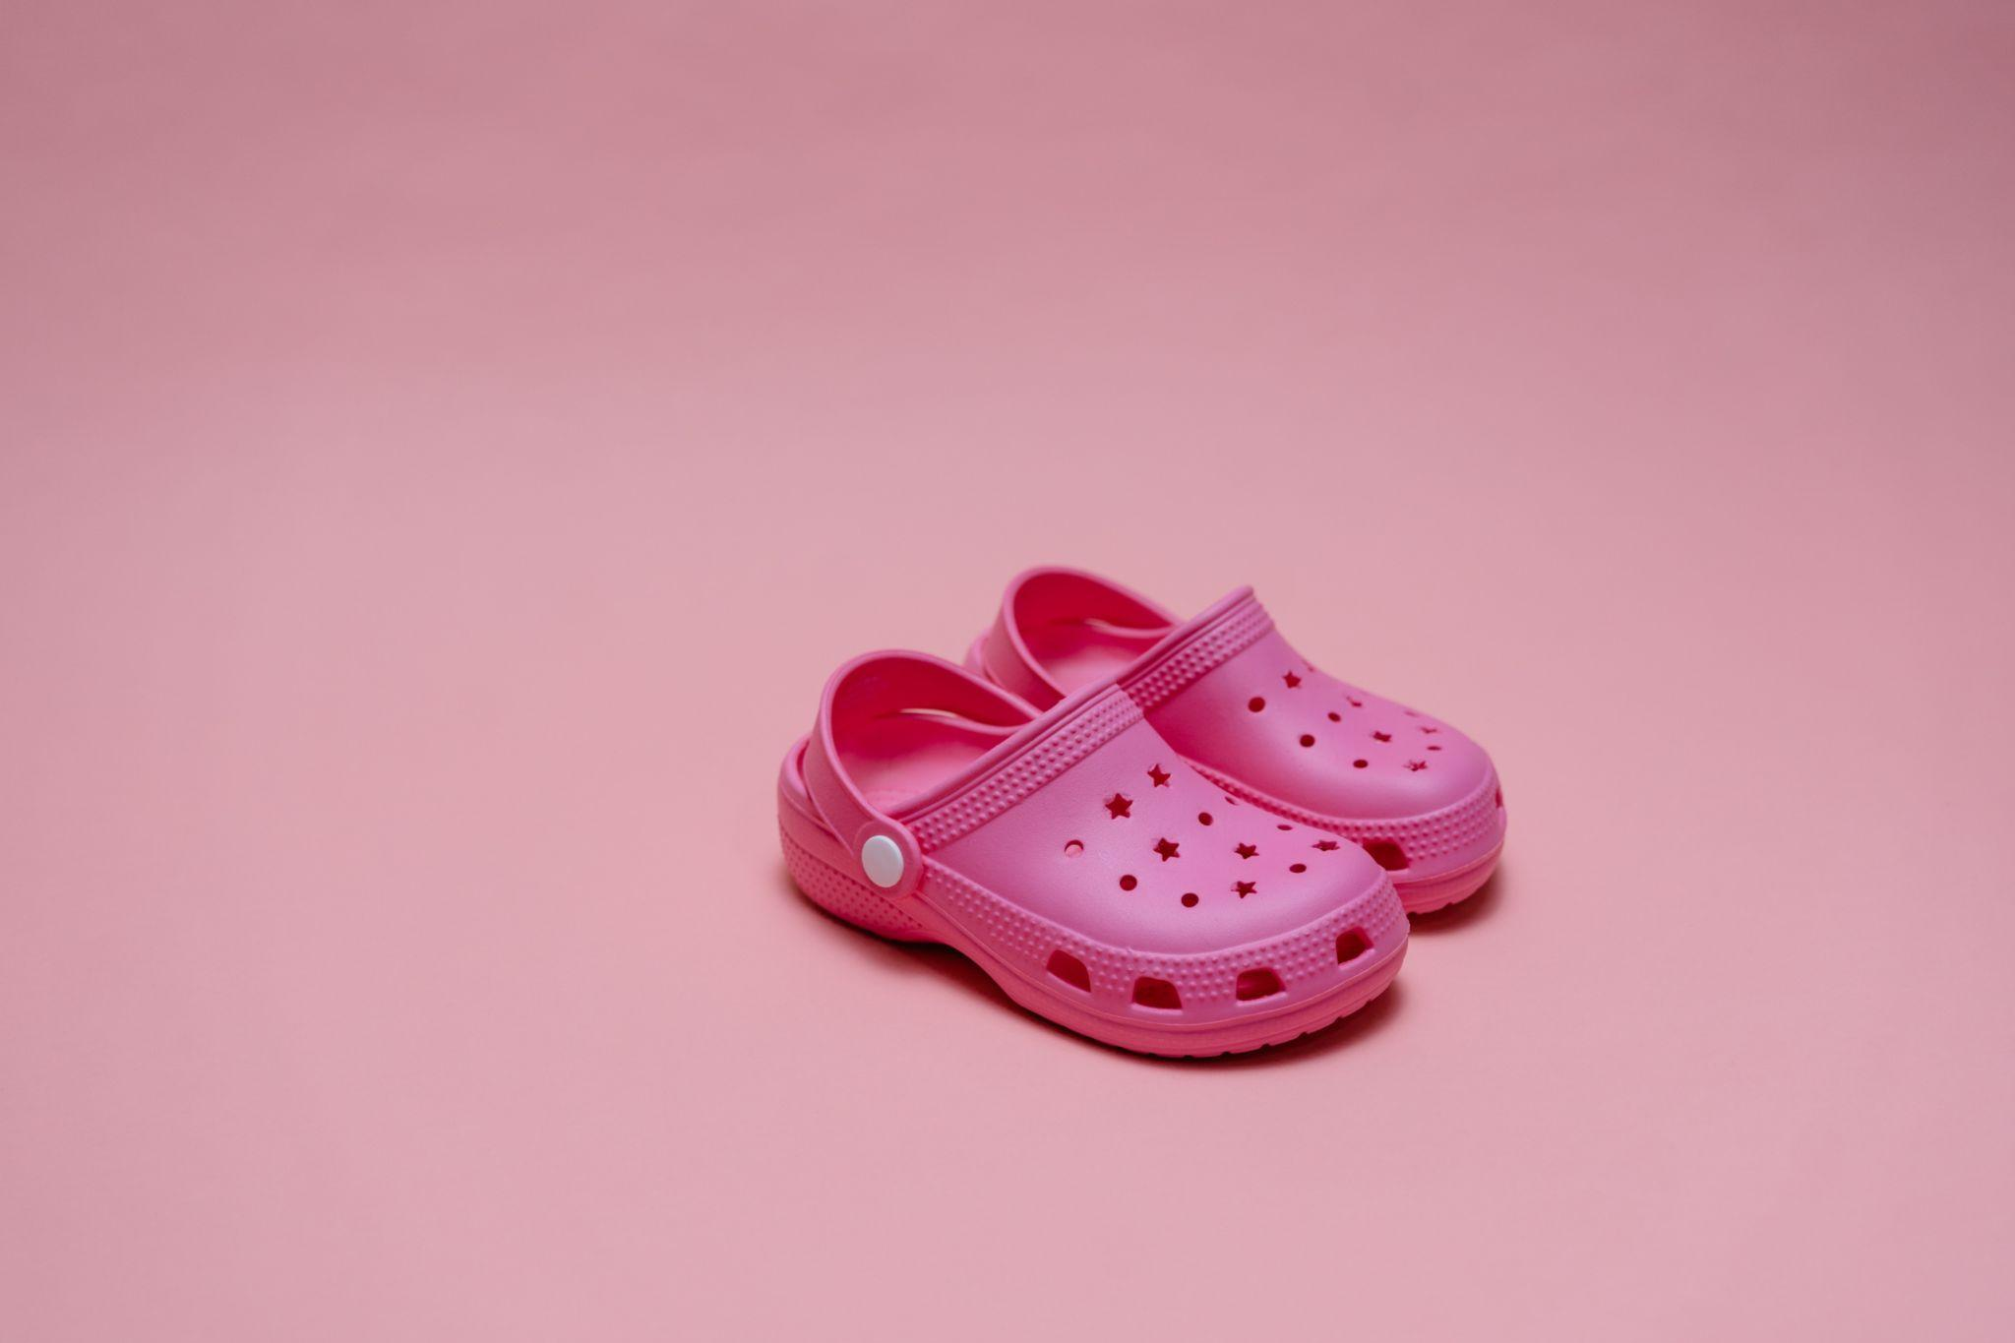

These days, the monochrome effect has become a trend on Instagram, making your feed stand out from others. Monochrome photos refer to the modification of a single tint. It could be any color that is pink, blue, green or grey, etc. This editing will highlight your photos and videos. When you limit your picture to a single shade, it makes your image look transparent, dramatic, and refreshing.

## The Neon Edit

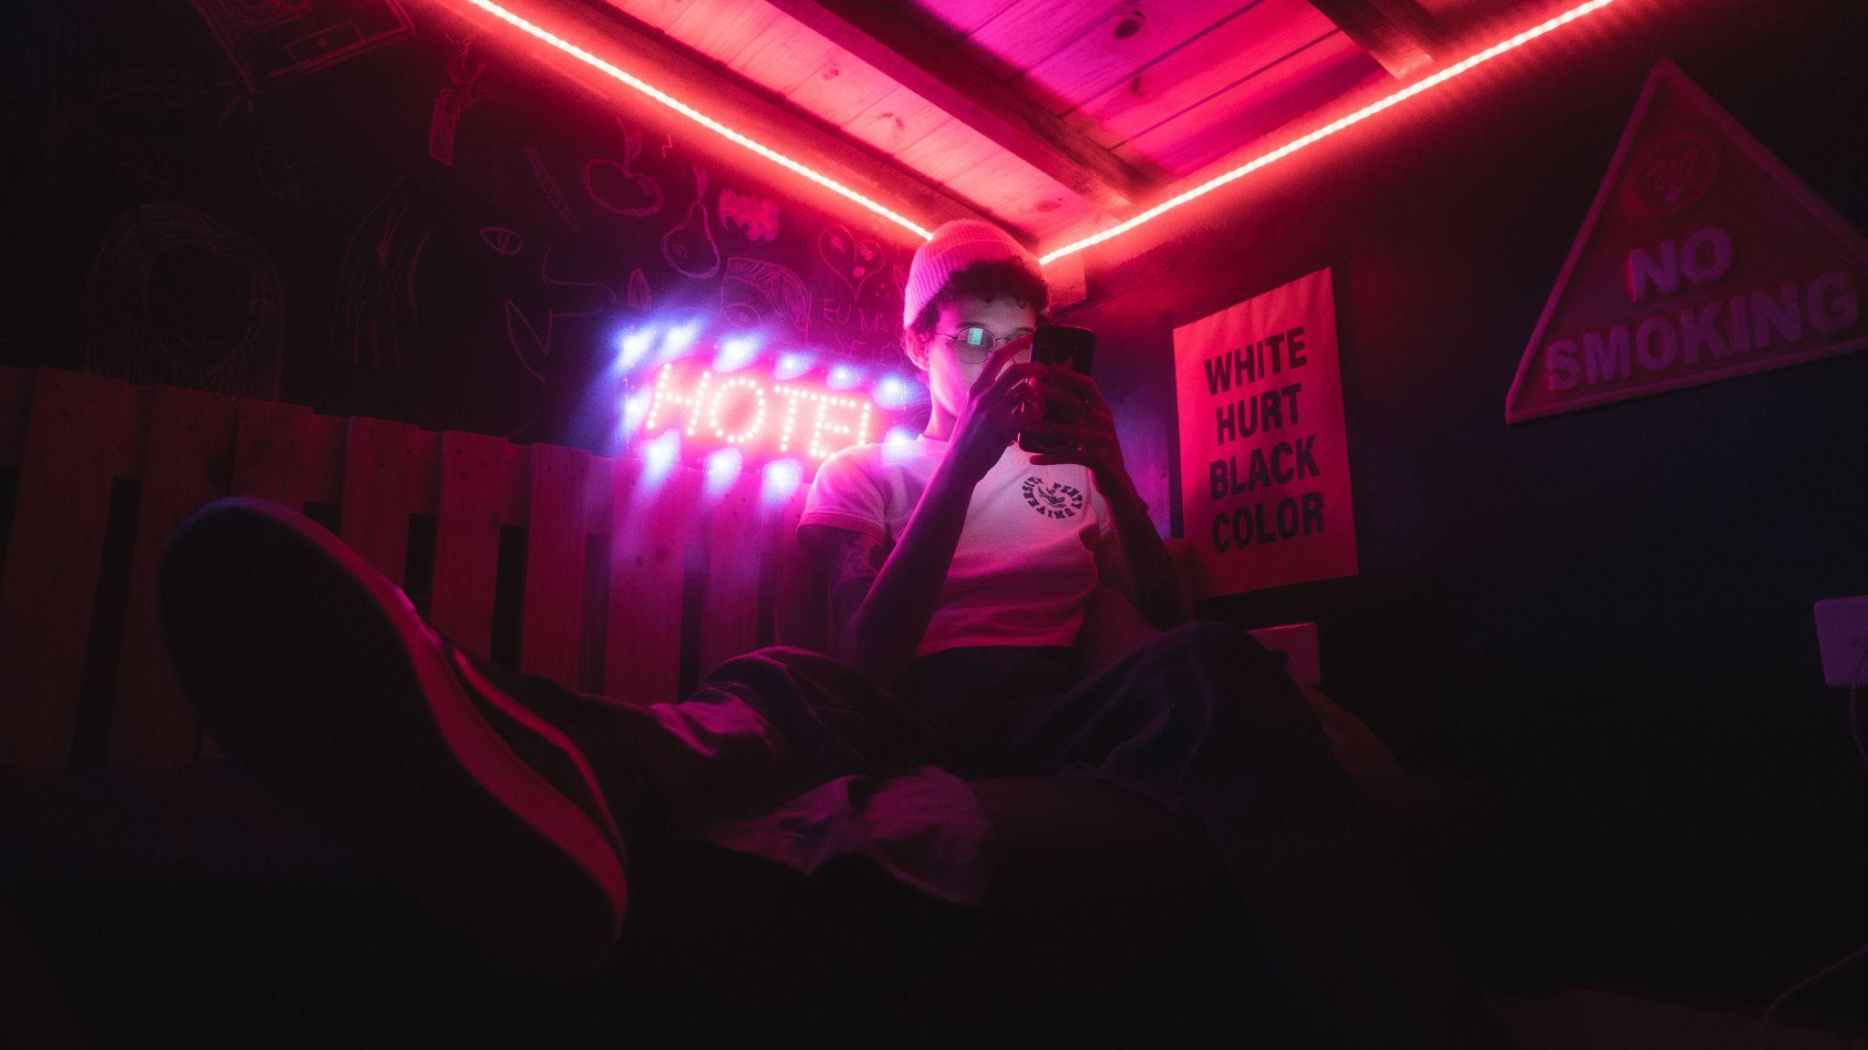

Someone addicted to social media must know how the neon edit has become a significant hit on Instagram. Everybody seems to be dipping in neon lights. This editing permits you to put emphasis on the main objective and become prominent as well. The neon editing gives an energetic and powerful look to any picture. This effect is also best for cinematic shots, fitness brands, and other portraits. One could achieve this look on the photographs by fixing pink and blue shades on either side of the picture.

## Colourpop Paper Tear Edit

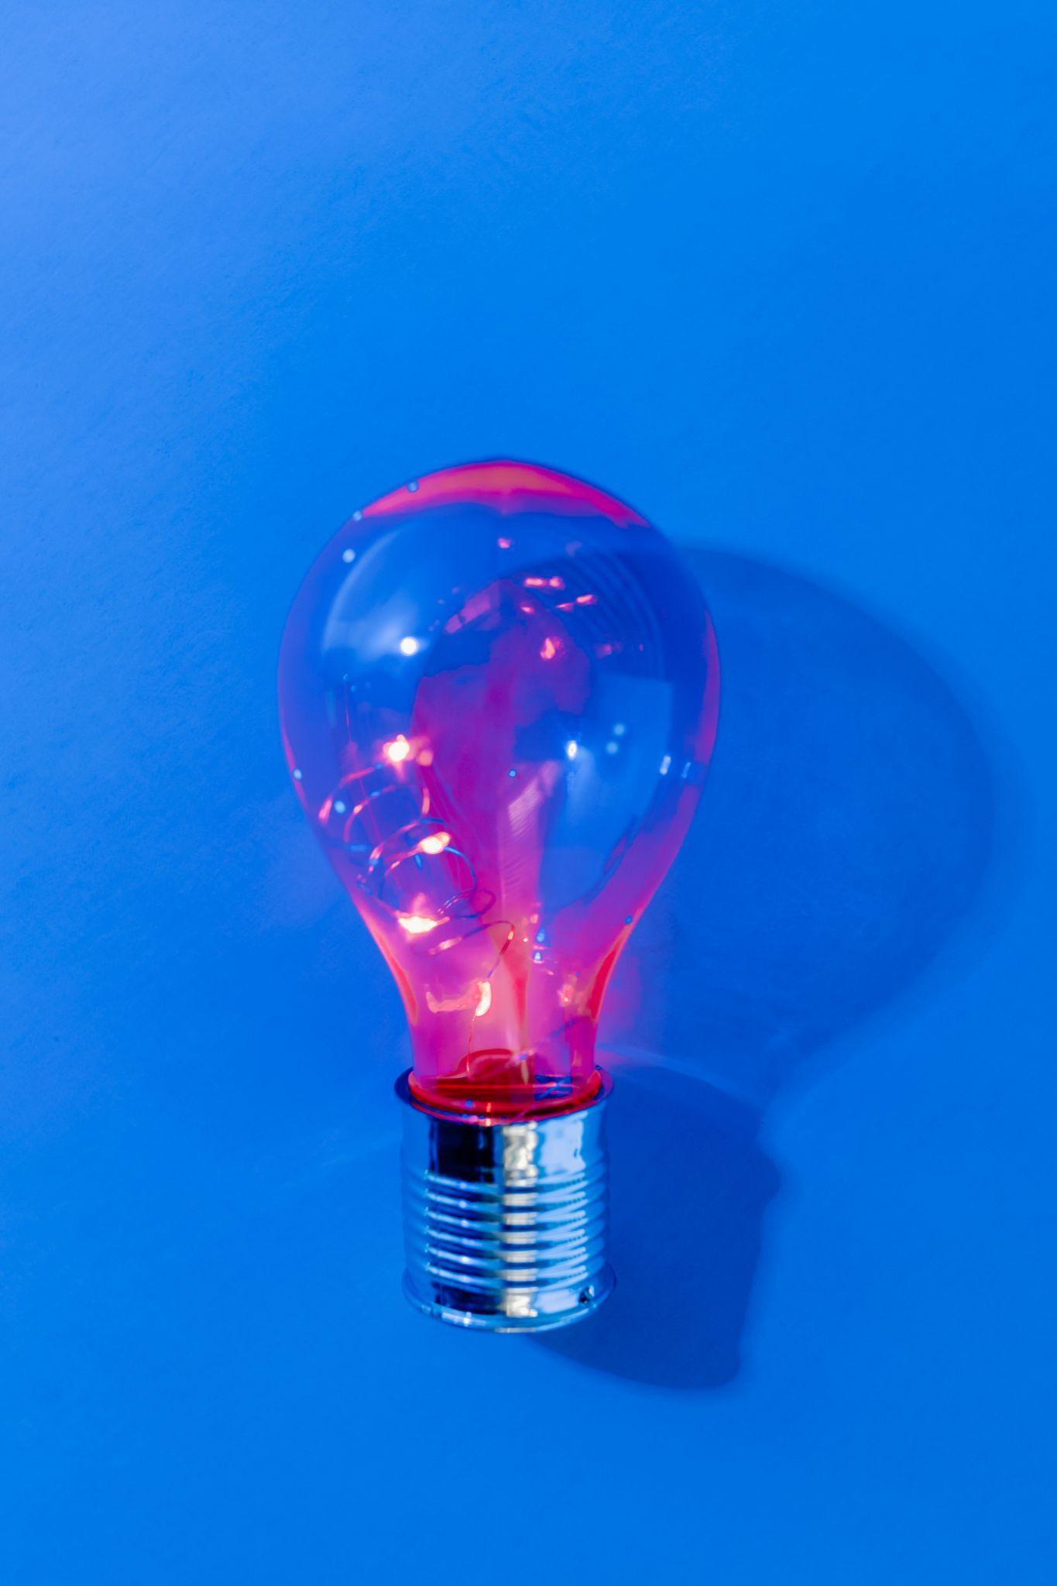

Colourpop Paper Tear is a prevalent form of art that has been hot for a long time. Now it has become a trend on Instagram as well. This editing looks exactly like its name refers to. It gives your picture an expression of a half ripped image joined with an unrelated photo at the back. It designs a complete aesthetic, surreal and distressed look for your feed. There are many ways to edit a post using Colourpop paper tear edit that is trending. You can also get this effect by using one of the photo cutter tools of cutout.pro that is you can cut out a certain part of the image and then combine it with another.

For instance, collage with ripped paper, abstract pattern or background, quote with ripped paper, and create a landscape.

## Carousel Edit

The Instagram Carousel Editing effect has taken a central stage among all the trends. Carousel is a type of editing where you can add photographs collectively in a single post. It is a great editing style for many brands as well. They can upload images with close-range photos and portraits from different angles in a single post.

## Instagram Borders

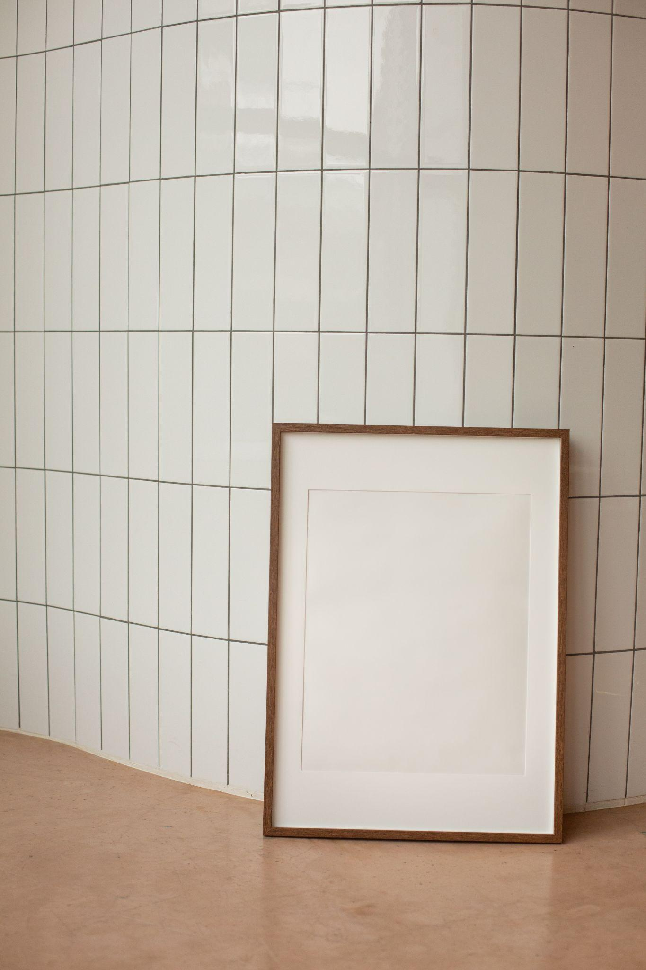

One more editing trend that has influenced people on Instagram is using borders around the picture. When you own a digital company, the key to attracting the mob is to create your posts trendy. Many huge brand names use borders around their posts to make them attractive and appealing. Many celebrities and brands use some trendy borders: photo borders, blurred borders, colored borders, and patterned borders.

## Text Overlays

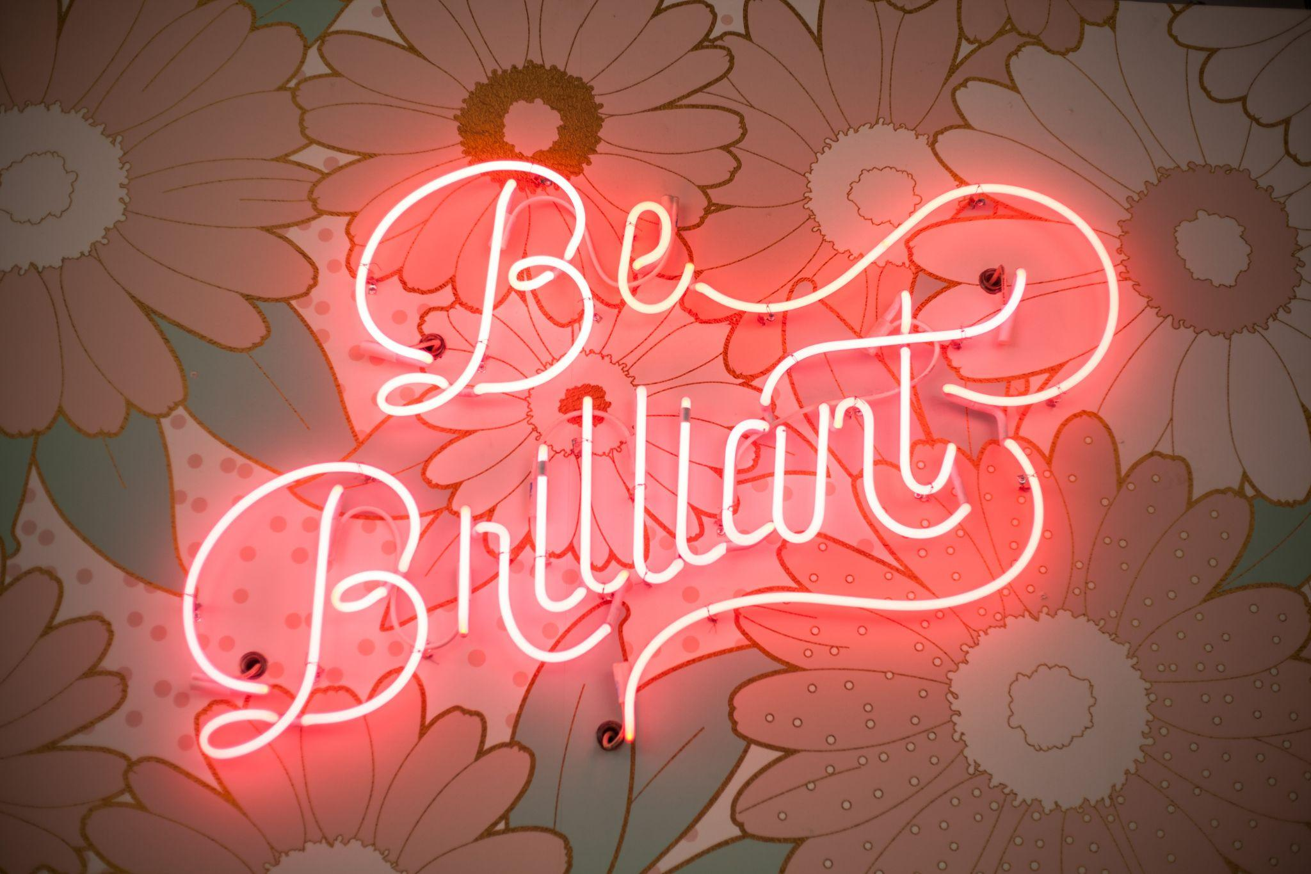

Text overlays have also created havoc on Instagram. It is an innovative and well-liked way to convey important stories. It is a powerful and engaging way to edit posts that many brands have been using. It communicates the necessary information at an instant look. Brands share details regarding the product using text overlays. Removing the background and replacing it with text overlays is also trending these days. One of the primary benefits of this edit is that there is no hurdle in visual branding. It is an ingenious and pleasing way to write texts on your posts.

## Animated Instagram Stories

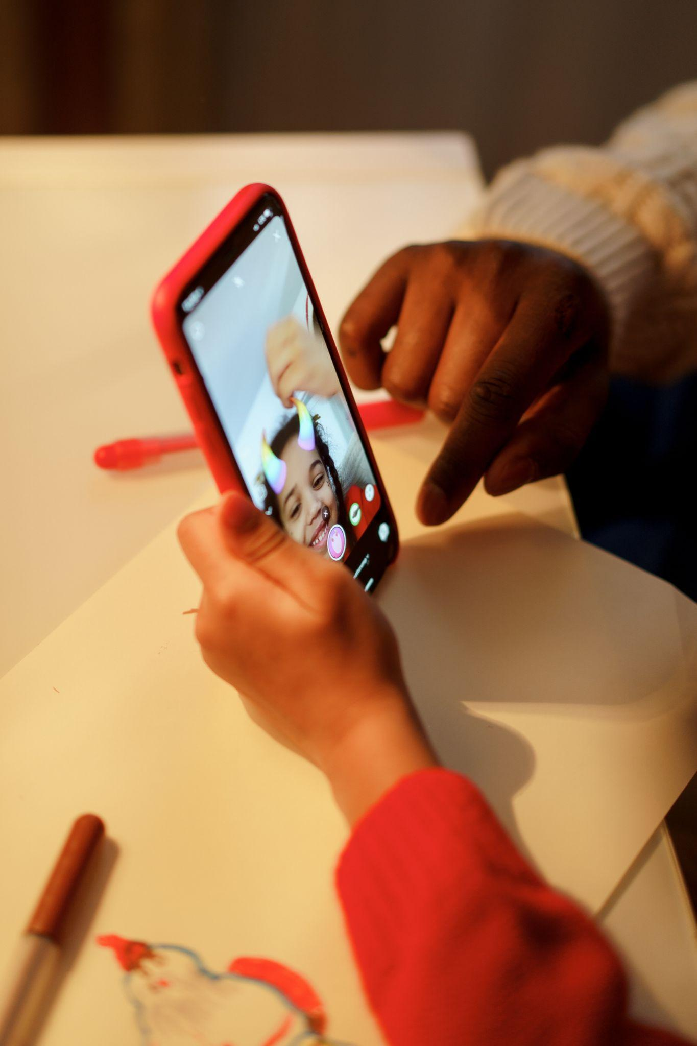

Animated Instagram stories have also been the center of attention for everyone on Instagram. Cartooning images is a great way to grab people’s attention. Now you don’t even need to buy expensive tools to animate your pictures because Photo Animer has created so much ease for everyone.

## Black and White Touch

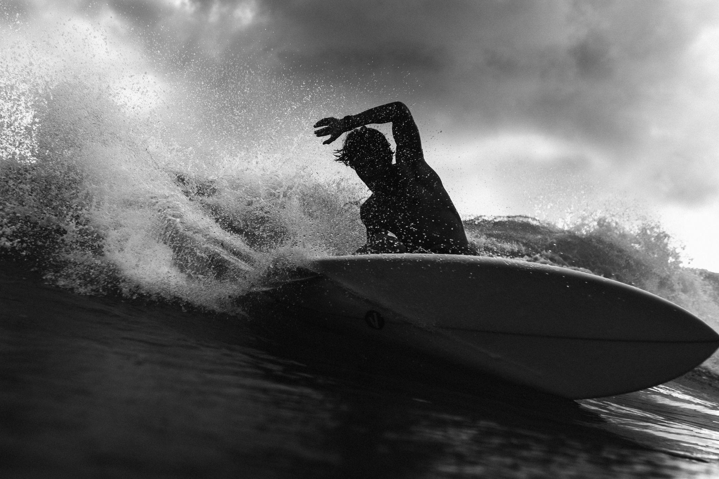

You can always depend on gen Z to make any old thing trendy. In this world full of colors, black and white have become a treat to the eye on Instagram. Many brands and bloggers practice this trend to stand prominent in the crowd. It pops up the shadows and features in such a great way that color cannot. Overall, a black and white vibe is undoubtedly a great path to undertake on Instagram. It's remarkable enough to attract people.

## Teal & Orange Look

Teal and orange editing is also a massive hit on Instagram these days. This look includes highlighting or enhancing the skin tone so that it stands out from the blue background and shadows. It gives a picture "sun-kissed" look. Many bloggers use this editing to make their feed prominent and attractive. It is not difficult to create a teal and orange look.

Did it ever happen that you scrolled through Instagram and experienced a pang of desire to create the same image as your favorite movie hero uploaded? You are not alone!!

Everyone loves those eye-catching and creative images that bloggers post every day. Research has it that the content with pertinent images grabs more attention than the content without them. How do they create such breathtaking pictures that make other people drool?

Of course, they use different tools to edit the photos that help them fascinate other people. If you also want to follow these Instagram trends by making your pictures look magical, cutout.pro is a fantastic website that could help you achieve your goal.

Now you don't need those complicated tools to keep pace with the trends, cutout.pro has created many tools that use artificial intelligence to make things work out in just a click. It can help you add different tints with the Photo Colorizer, cut out backgrounds, remove people from photos, cut pictures, or remove objects from photos. Besides cutting out things, it can also add backgrounds or different locations in the photographs. You can transform your images into objects of art using powerful, innovative aspects of the cutout.pro tools, like, colorful effects, removing backgrounds to replace it with another background and animation using cutout.pro.

## Bottom Line

Making charming, alluring, and pleasing Instagram profiles is significant for all the Instagram bloggers or influencers to get more fan following and visits on the profile. Along with following trends, don't be scared of trying out new things. If you are confused about how your images will look, try them in advance using tools by cutout.pro.